KUBERNETES TASK -03
- Create a ClusterIP service for an Apache web server pod.

Step 1: Create Apache Pod YAML
Create a file:
- nano apache-pod.yaml
Paste this:
apiVersion: v1
kind: Pod
metadata:
name: apache-pod
labels:
app: apache
spec:
containers:
- name: apache-container
image: httpd:latest
ports:
- containerPort: 80
Save and exit (CTRL+O, ENTER, CTRL+X)

Step 2: Deploy the Pod
- kubectl apply -f apache-pod.yaml
Check Pod status:
- kubectl get pods
Wait until you see:
apache-pod Running

✅ Step 3: Create ClusterIP Service YAML
Create another file:
- nano apache-service.yaml
Paste this:
apiVersion: v1
kind: Service
metadata:
name: apache-service
spec:
type: ClusterIP
selector:
app: apache
ports:
- protocol: TCP
port: 80
targetPort: 80
Save and exit.

Step 4: Deploy the Service
- kubectl apply -f apache-service.yaml

✅ Step 5: Verify Service
- kubectl get svc
Output will look like:
NAME TYPE CLUSTER-IP PORT(S)
apache-service ClusterIP 10.x.x.x 80/TCP

Step 6: Test the Service (Important)
Run a temporary test pod:
- kubectl run testpod --image=busybox -it --rm -- /bin/sh
Inside the pod, run:
- wget -qO- http://apache-service
👉 If everything is correct, you will see Apache default HTML page.
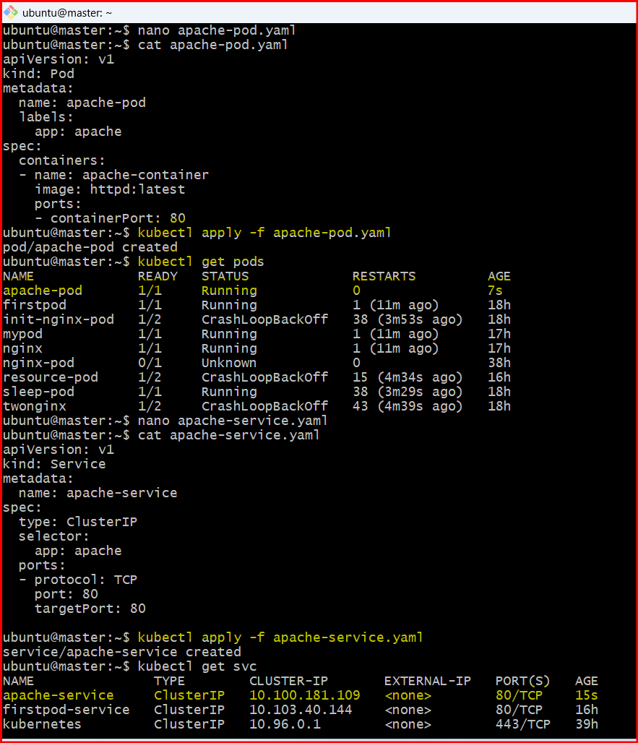
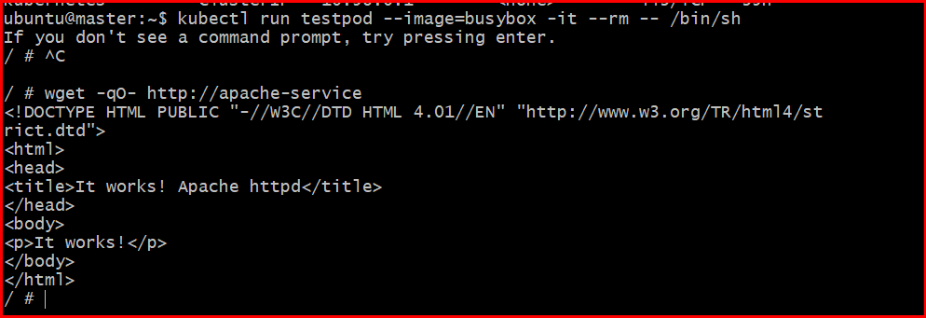
- Expose an Nginx pod externally using a NodePort service.

Step 1: Create NGINX Pod YAML
- nano nginx-pod.yaml
Paste:
apiVersion: v1
kind: Pod
metadata:
name: nginx-pod
labels:
app: nginx
spec:
containers:
- name: nginx-container
image: nginx:latest
ports:
- containerPort: 80
Save and exit.

Step 2: Deploy the Pod
- kubectl apply -f nginx-pod.yaml
Check status:
- kubectl get pods
Wait until:
- nginx-pod Running

Step 3: Create NodePort Service YAML
- nano nginx-service.yaml
Paste:
apiVersion: v1
kind: Service
metadata:
name: nginx-service
spec:
type: NodePort
selector:
app: nginx
ports:
- protocol: TCP
port: 80
targetPort: 80
nodePort: 30007 # You can choose between 30000–32767

Step 4: Deploy the Service
- kubectl apply -f nginx-service.yaml

Step 5: Verify Service
- kubectl get svc
Example output:
- NAME TYPE CLUSTER-IP PORT(S)
nginx-service NodePort 10.x.x.x 80:30007/TCP

Step 6: Access NGINX from Browser
Find your node IP:
- kubectl get nodes -o wide
Now open in browser:
- http://<NODE-IP>:30007
👉 You should see the NGINX welcome page.
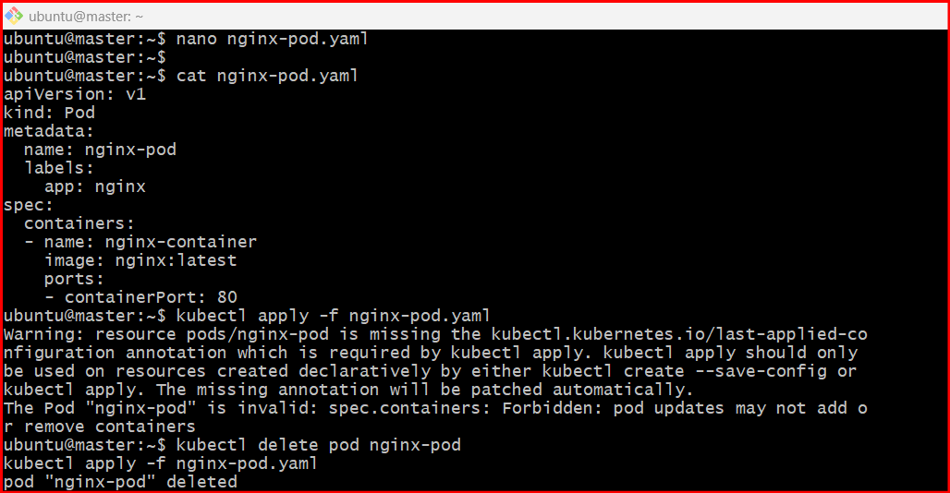
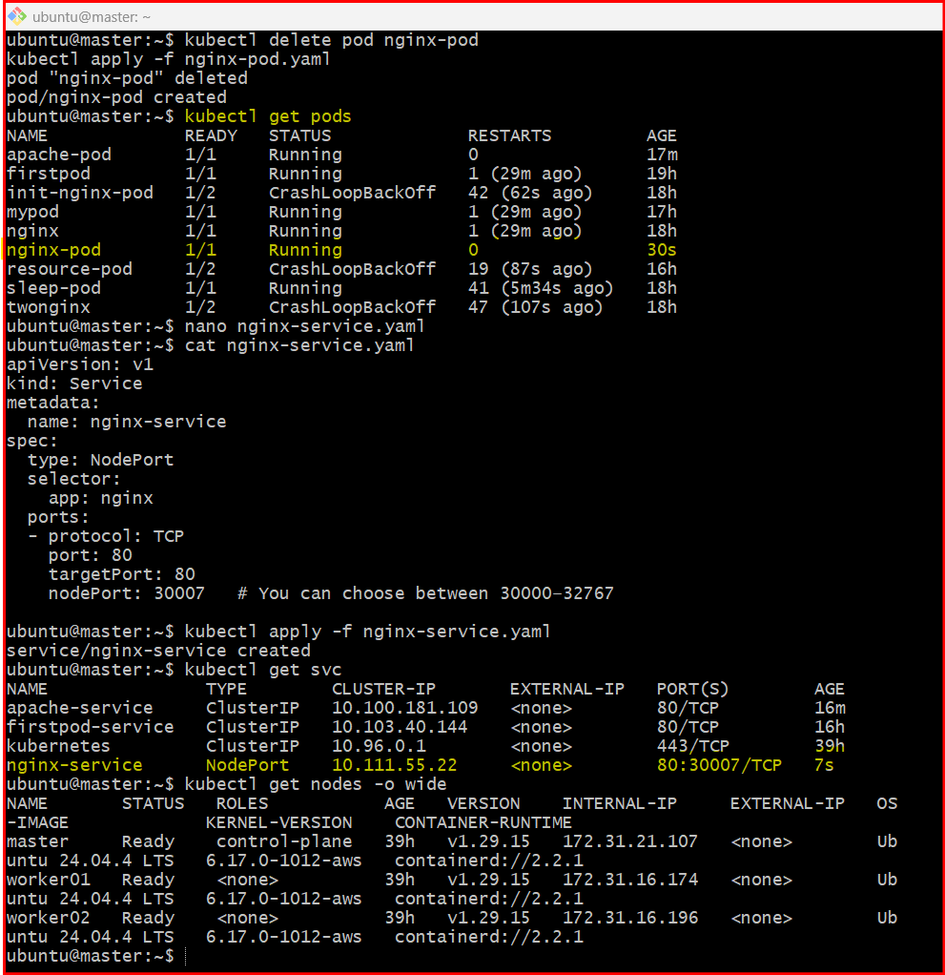
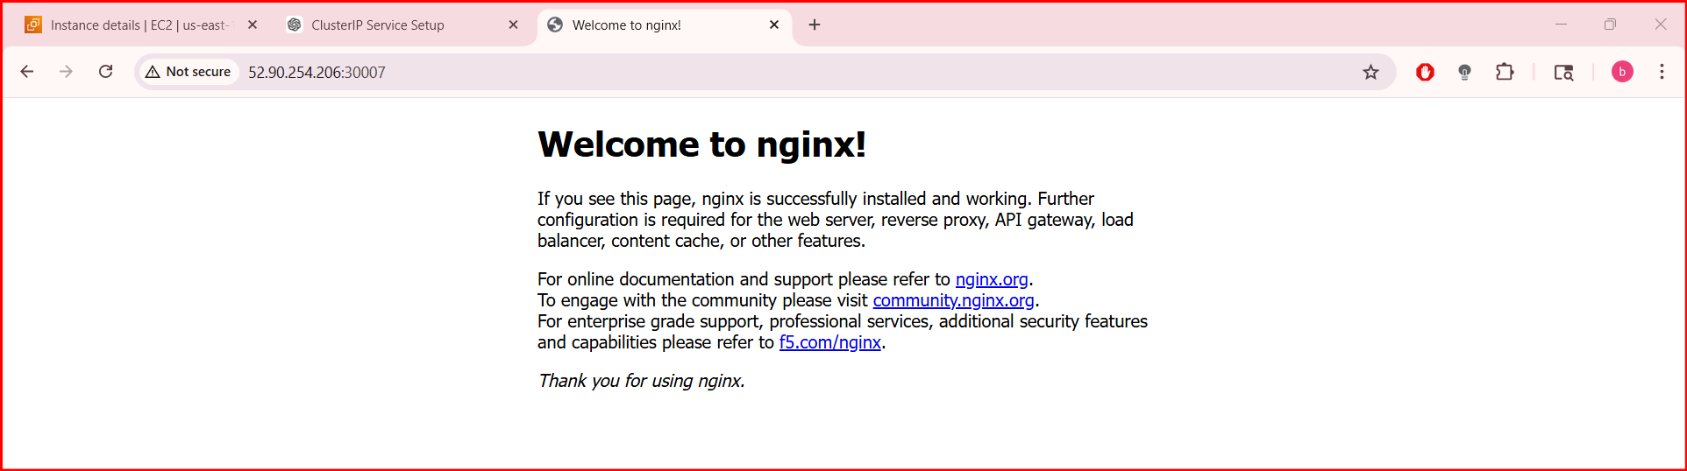
- Deploy a ReplicationController to maintain 3 replicas of an Nginx pod.

Step 1: Create YAML file
- nano nginx-rc.yaml
Paste this:
apiVersion: v1
kind: ReplicationController
metadata:
name: nginx-rc
spec:
replicas: 3
selector:
app: nginx
template:
metadata:
labels:
app: nginx
spec:
containers:
- name: nginx-container
image: nginx:latest
ports:
- containerPort: 80
Save and exit (CTRL+O, ENTER, CTRL+X)

Step 2: Deploy the ReplicationController
- kubectl apply -f nginx-rc.yaml

Step 3: Verify Pods
- kubectl get pods
👉 You should see 3 pods running, something like:
- nginx-rc-xxxxx Running
nginx-rc-yyyyy Running
nginx-rc-zzzzz Running

Step 4: Verify ReplicationController
- kubectl get rc
Output:
NAME DESIRED CURRENT READY
nginx-rc 3 3 3

Step 5: Test Self-Healing (Important)
Delete one pod:
- kubectl delete pod <pod-name>
👉 Then check again:
kubectl get pods
✔ You’ll see a new pod automatically created
➡️ This proves the ReplicationController is maintaining 3 replicas
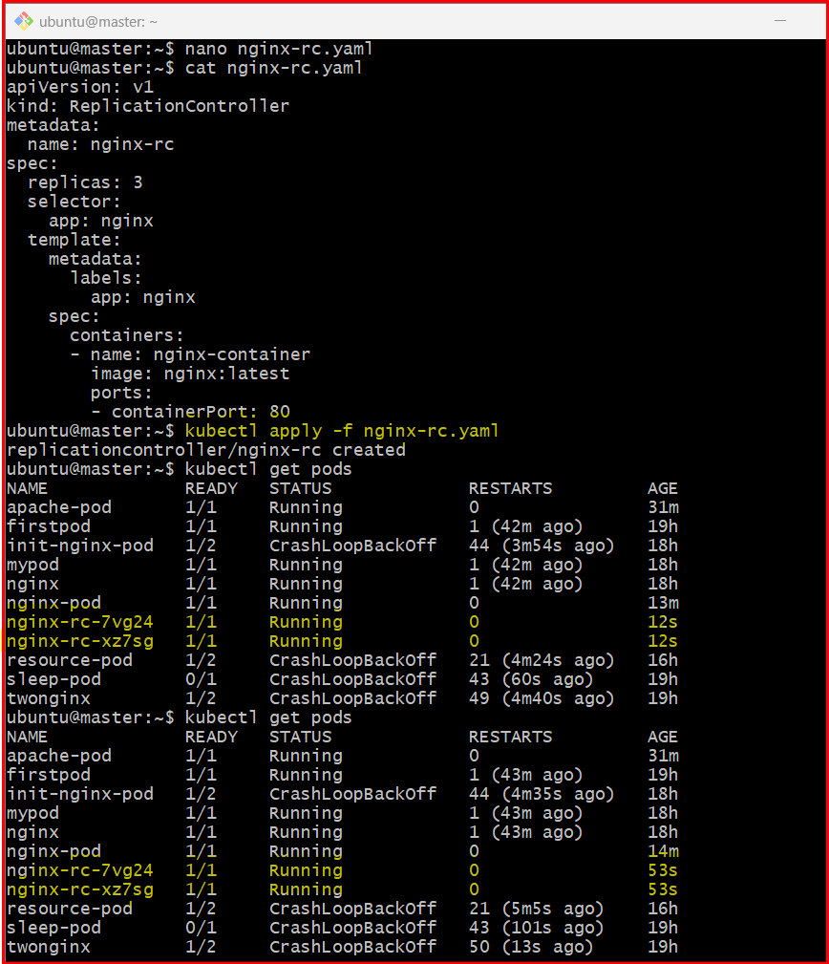
- Here you can only see two nginx-rc-XXXX but we have given 3 as replica’s , so the one is taken from the existing pod which does not have a label in it.
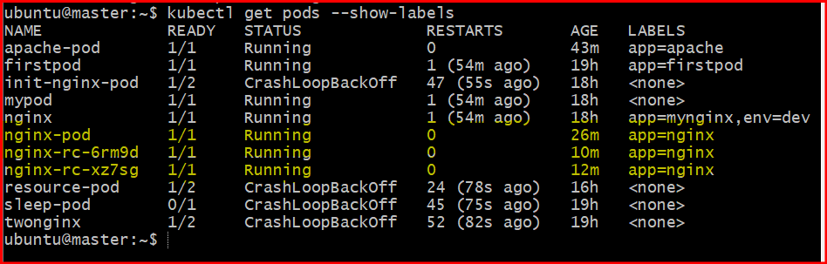

- I have deleted one pod with name “nginx-rc-7vg24” but ReplicationController is created another one to maintain replica’s that is three
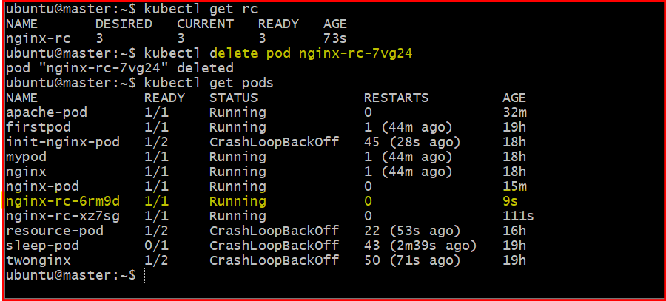

- Scale the ReplicationController from 3 replicas to 5 replicas.

- You can scale a ReplicationController from 3 → 5 replicas in two simple ways.

Method 1: Using kubectl scale (fastest)
- kubectl scale rc nginx-rc --replicas=5

Verify scaling
- kubectl get rc
You should see:
NAME DESIRED CURRENT READY
nginx-rc 5 5 5
Check pods:
- kubectl get pods
👉 Now you’ll see 5 running pods

✅ Method 2: Edit YAML (manual way)
- kubectl edit rc nginx-rc
Change:
- replicas: 3
➡️ to:
- replicas: 5
- Save and exit.
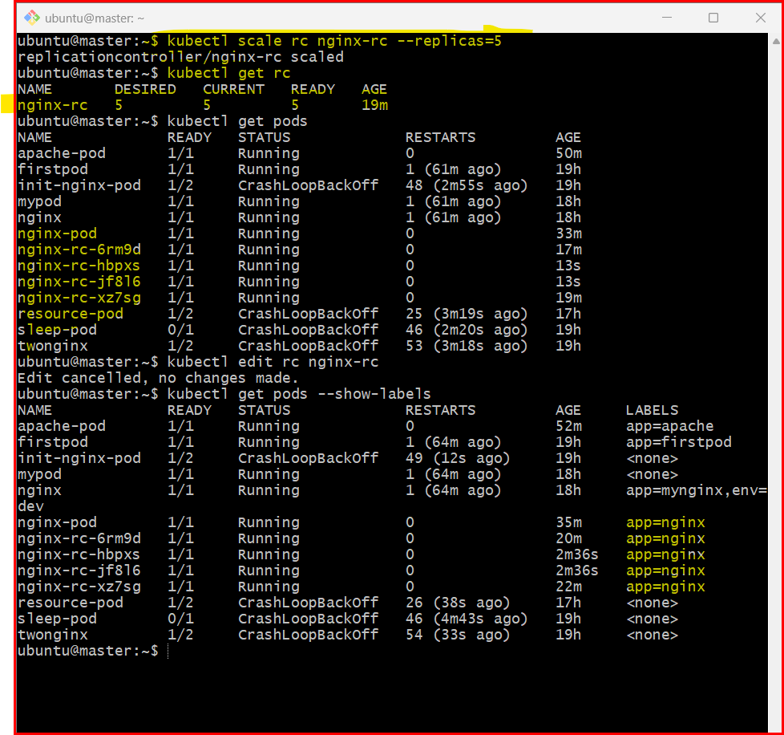

- One pod is taken from existing one and other four is created new with nginx-rc-XXXXX .
- You can identify by labels also.

- Create a ReplicaSet to manage pods based on multiple labels (prod and test).

Step 1: Create YAML file
- nano nginx-rs.yaml
Paste this:
apiVersion: apps/v1
kind: ReplicaSet
metadata:
name: nginx-rs
spec:
replicas: 4
selector:
matchLabels:
app: nginx
env: prod # change to test if needed
template:
metadata:
labels:
app: nginx
env: prod # must match selector
spec:
containers:
- name: nginx-container
image: nginx:latest
ports:
- containerPort: 80

Step 2: Apply ReplicaSet
- kubectl apply -f nginx-rs.yaml

Step 3: Verify
- kubectl get rs
- kubectl get pods --show-labels

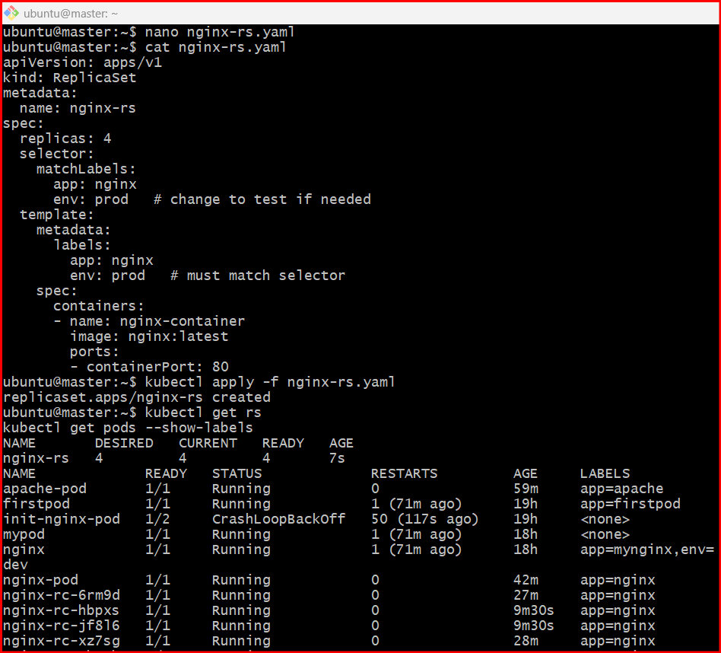
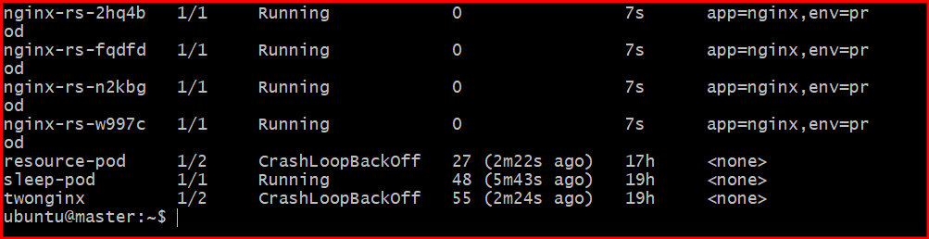
- Deploy a ReplicaSet that excludes pods with the label backend.

Step 1: Create YAML file
- nano nginx-rs-exclude.yaml
Paste this:
apiVersion: apps/v1
kind: ReplicaSet
metadata:
name: nginx-rs-exclude
spec:
replicas: 3
selector:
matchExpressions:
- key: tier
operator: NotIn
values:
- backend
template:
metadata:
labels:
app: nginx
tier: frontend # NOT backend, so it matches
spec:
containers:
- name: nginx-container
image: nginx:latest
ports:
- containerPort: 80

Step 2: Apply ReplicaSet
- kubectl apply -f nginx-rs-exclude.yaml

Step 3: Verify
- kubectl get rs
- kubectl get pods --show-labels
👉 You should see pods with:
tier=frontend
and no pods with tier=backend

- kubectl run test-backend --image=nginx --labels="tier=backend"

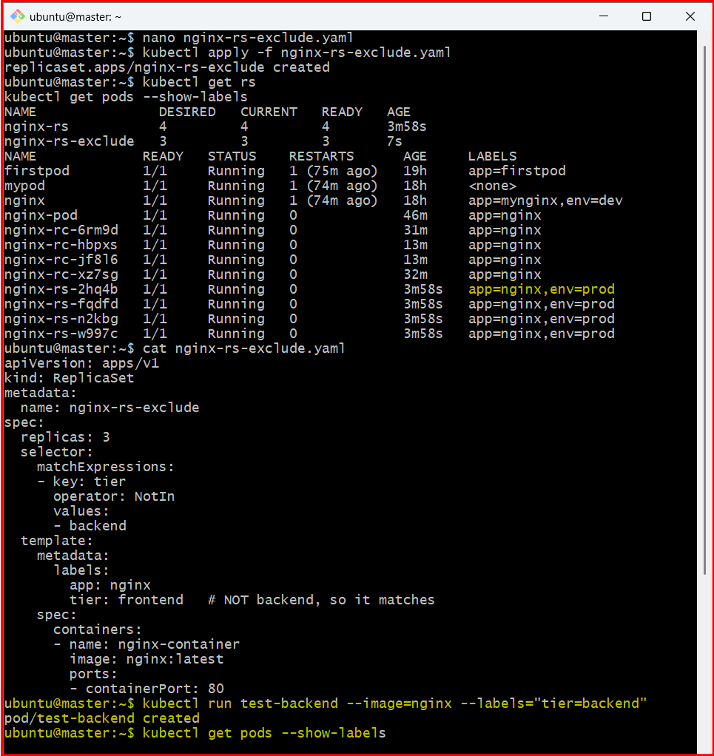

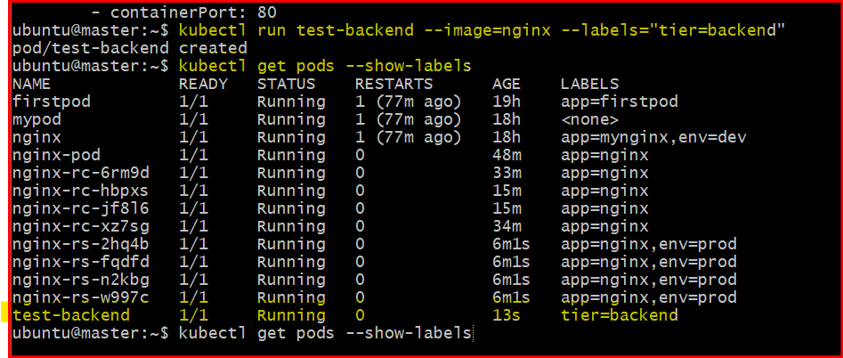

- Test load balancing across multiple pods using a NodePort service.

Step 1: Create Deployment (multiple pods)
- nano nginx-deploy.yaml
Paste:
apiVersion: apps/v1
kind: Deployment
metadata:
name: nginx-deploy
spec:
replicas: 3
selector:
matchLabels:
app: nginx
template:
metadata:
labels:
app: nginx
spec:
containers:
- name: nginx
image: nginx:latest
ports:
- containerPort: 80
Apply it:
- kubectl apply -f nginx-deploy.yaml
Verify pods:
- kubectl get pods -o wide

Step 2: Expose using NodePort Service
- nano nginx-service.yaml
Paste:
apiVersion: v1
kind: Service
metadata:
name: nginx-service
spec:
type: NodePort
selector:
app: nginx
ports:
- port: 80
targetPort: 80
nodePort: 30007
Apply:
- kubectl apply -f nginx-service.yaml

Step 3: Get Node IP
- kubectl get nodes -o wide
Example:
192.168.1.10

Step 4: Test in Browser / Curl
Open in browser:
http://<NODE-IP>:30007
OR use curl:
curl http://<NODE-IP>:30007

Step 5: Confirm Load Balancing (IMPORTANT)
By default, NGINX shows same page — so you won’t see which pod responds.
So modify pods to show hostname:
Run this command:
- kubectl get pods
- Then exec into each pod one by one:
- kubectl exec -it <pod-name> -- /bin/bash
- Inside pod:
- echo "Hello from $(hostname)" > /usr/share/nginx/html/index.html
- exit
- Repeat for all pods.

✅ Step 6: Test Again
Now run multiple times:
- curl http://<NODE-IP>:30007
Output will change:
- Hello from nginx-deploy-abc
- Hello from nginx-deploy-xyz
- Hello from nginx-deploy-pqr
This proves load balancing is working

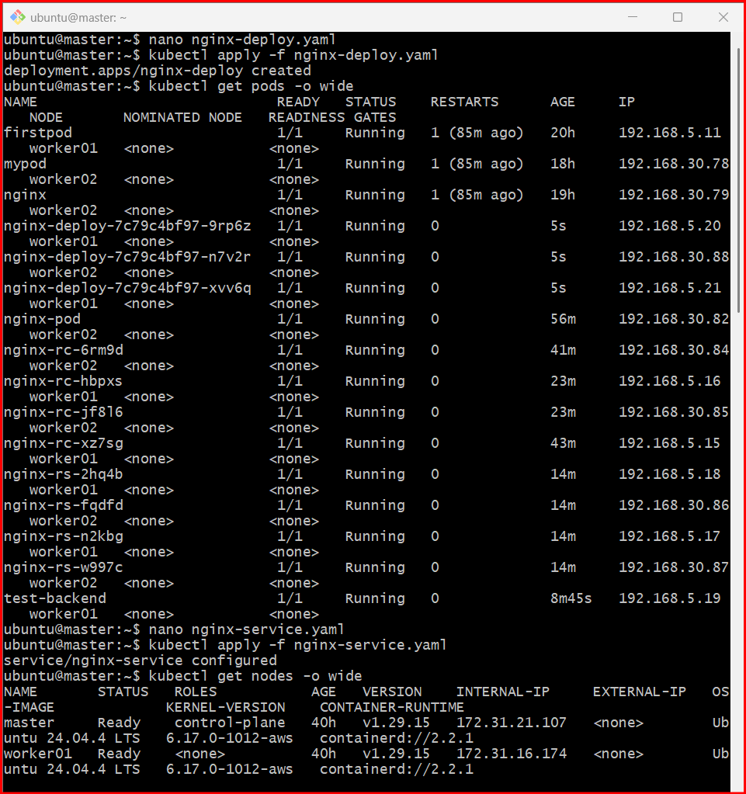

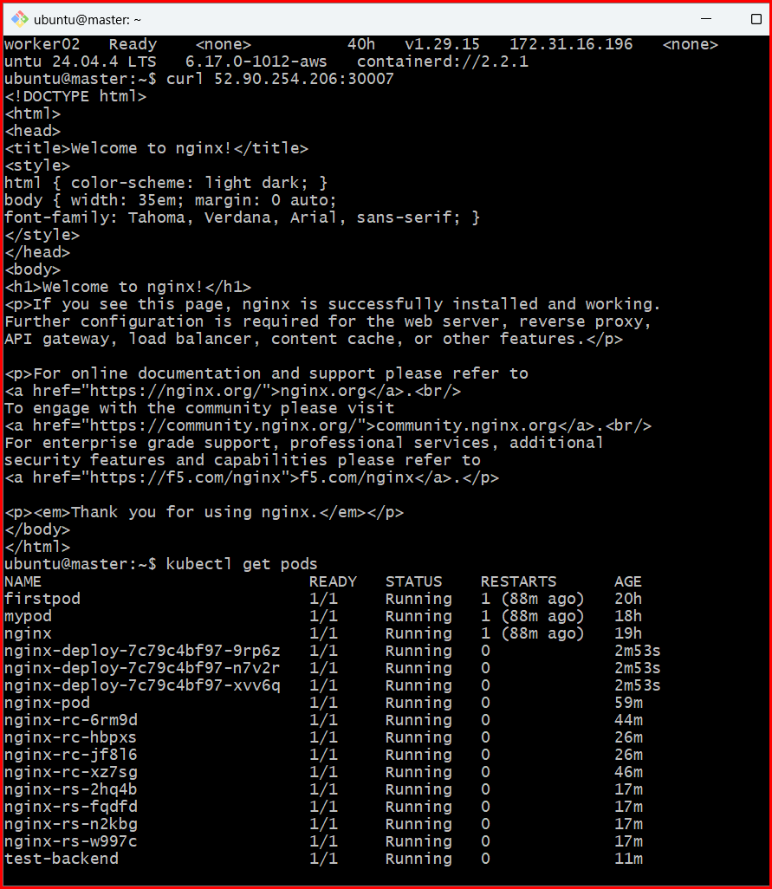

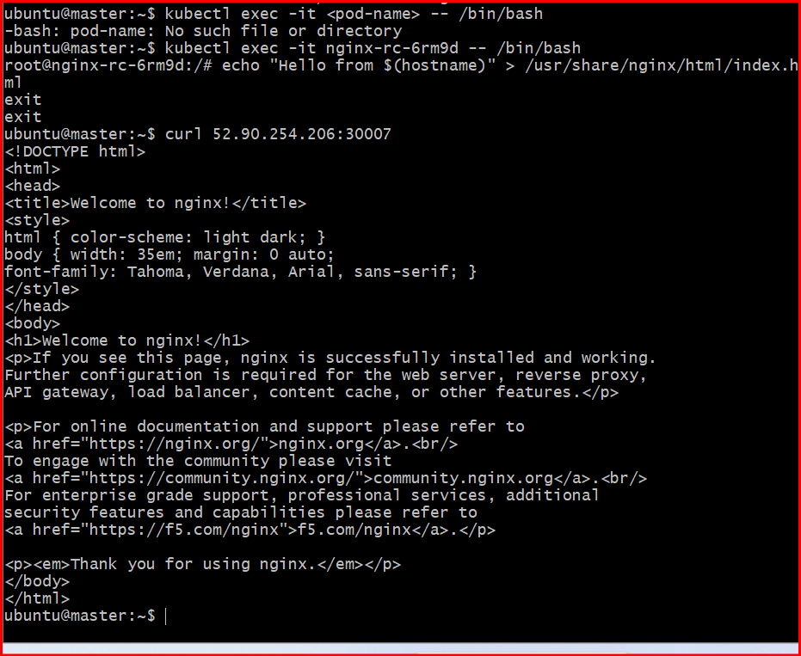
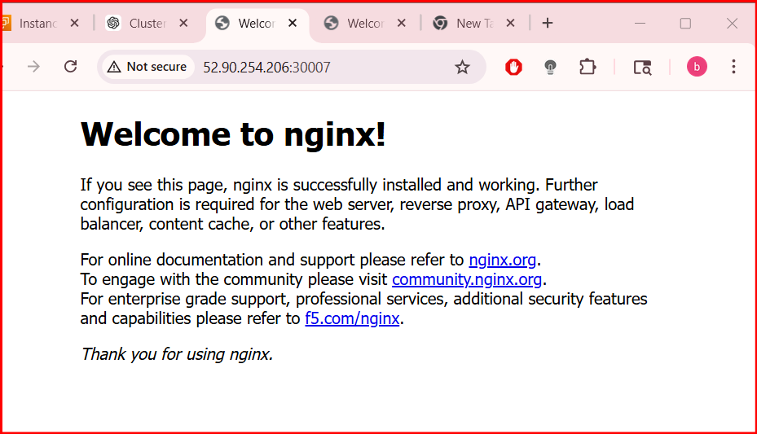
- Delete a ReplicationController without affecting the running pods.

Correct Command
- kubectl delete rc nginx-rc --cascade=orphan

What this does
- Deletes the ReplicationController
- Keeps all existing pods running
- Pods become orphaned (no controller managing them)

Verify
Check RC is deleted:
- kubectl get rc
Check pods still running:
- kubectl get pods
u’ll see pods still in Running state
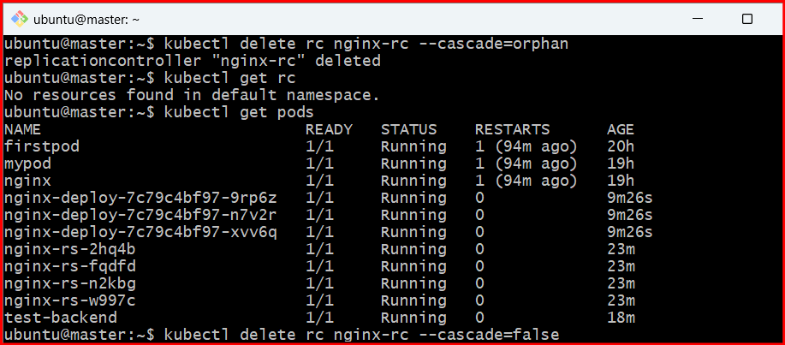

v

